\\This post explains the steps to format a list with a hanging indent, using Microsoft Word 2010. In this example, I am starting out with a list of references which are indented to the left.  
  
[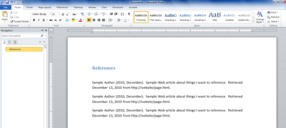](http://1.bp.blogspot.com/_uosqV-6EfeM/TQbJdzt5YCI/AAAAAAAAAfA/B42NFwwtqzI/s1600/references1.png)

1. Highlight the text to be formatted.  
2. On the Ribbon, next to the word "Paragraph" click the chevron to open the paragraph formatting window.  
3. Beneath the Indentation heading, set the "Special" field to "Hanging" and set the "By" field to "0.5."  
4. Click OK  
  
[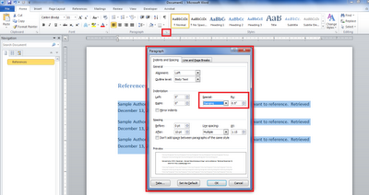](http://4.bp.blogspot.com/_uosqV-6EfeM/TQbJaM8XWHI/AAAAAAAAAe4/WWMgvdp-224/s1600/references2.png)

5. At that point, the list should be reformatted with a hanging indent.